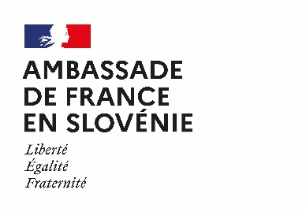
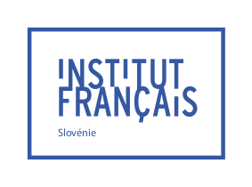
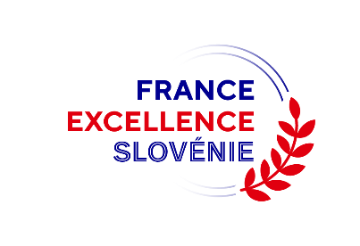

Application form for the France Excellence Slovénie

High Level Scientific Stay Scholarship Program (SSHN)

2026

The application form and the required documents must be sent to the French Institute of Slovenia before Friday, May 15th 2026.

GENERAL INFORMATION
Last Name : ___________________________________________ First name :___________________________________________

Gender: Female Male X

Nationality : __________________________________

Date and place of birth (city and country): _____________________________________________________________________

Current address:____________________________________________________________________________

Phone number:__________________________ Email address :______________________________________

YOUR ACADEMIC BACKGROUND
Last completed degree (level, subject, university): ____________________________________________________________
__________________________________________________________________________________________________________________________________________________________________________________

Title of your dissertation and year of completion (or expected year of completion) : _________________________________________________________________________________________
___________________________________________________________________________________________________________________________________________________________________________________________________________________________________________________________________________
_________________________________________________________________________________________

Have you ever studied or conducted research abroad? If so, please indicate the academic year, the institutional frame of your stay (Erasmus+, independent stay, etc.), as well as the name of the university/institution: _______________________________________________________________________________________________________________
__________________________________________________________________________________________________________________________________________________________________________________

Have you ever conducted research in France? If so, please indicate the duration of your stay and the name of the host laboratory: _________________________________________________________________________________________
__________________________________________________________________________________________________________________________________________________________________________________

Have you ever learned French? If so, please indicate your level of proficiency in accordance with the Common European Framework of Reference for Languages (CEFR): _____________________________________________________
__________________________________________________________________________________________________________________________________________________________________

How have you heard about the High-Level Scientific Stay opportunity?
___________________________________________________________________________________________________________________________________________________________________________________________________________________________________________________________________________

Optional : Have you passed a DELF (diplôme d’études en langue française) or DALF test (diplôme approfondi de langue française), certifications in French as a foreign language ? If so, please indicate the level passed: _______________________________________________________________________________________________________________

YOUR PROJECT OF STAY
Estimated duration of your stay in France: ___________________________________________________________

Estimated departure date: ________________________________________________________________________________________________________________

Host university / laboratory: __________________________________________________________________________________

Title of the planned research: ___________________________________________________________
____________________________________________________________________________________
____________________________________________________________________________________

Is your project part of a PHC Proteus Program? If so, please specify: ________________________________________________________________________________________________________________________________________________________________________

Have you been accepted yet in the host establishment ? Yes No

Contact details for the partner research team in France (name and function): _________________________________________________________________________________________
_________________________________________________________________________________________

Contact details for the supervisor/ manager in Slovenia (name and function): _________________________________________________________________________________________
_________________________________________________________________________________________

Will you get any other financial support? Yes No

If so, please specify the type of financial support obtained / planned: __________________________________________________________________________________________________________________________________________________________________________________

ADDITIONAL COMMENTS
_________________________________________________________________________________________
_________________________________________________________________________________________
_________________________________________________________________________________________
_________________________________________________________________________________________
_________________________________________________________________________________________

This application form, duly completed and signed, must be submitted along with the required documents listed in the call for application before Friday, May 15th 2026 by e-mail.

An acknowledgement of receipt will be sent to you by e-mail to confirm the receivability of the application. If you don’t receive it, please reach out to the French Institute.

Sarah Trudelle
Attachée for Scientific and Academic Cooperation
French Institute of Slovenia
Breg 12 – 1000 Ljubljana
sarah.trudelle@institutfrance.si

Place: _____________________________________

Date: ______________________________________

Signature:

