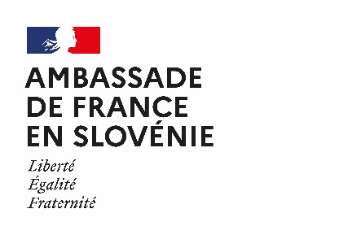
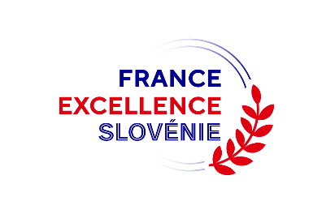
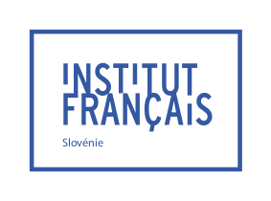

Application form for the France Excellence Slovénie Scholarship Program

Category Bachelor/Master

Academic year 2026/2027

The application form and the required documents must be sent to the French Institute of Slovenia by Wednesday, May 20th 2026.

GENERAL INFORMATION
Last Name : ___________________________________________ First name :___________________________________________

Gender: F M X

Nationality : __________________________________

Date and place of birth (city and country): ______________________________________________________________________

Current address:____________________________________________________________________________

Phone number:_____________________________________________________________________________
Email address :_____________________________________________________________________________

YOUR ACADEMIC BACKGROUND
Last completed degree (level, subject, university): ____________________________________________________________
__________________________________________________________________________________________________________________________________________________________________________________

Current enrollment (level, subject, university): ________________________________________________________________
__________________________________________________________________________________________________________________________________________________________________________________

Have you ever studied abroad? If so, please indicate the academic year, the institutional frame of your stay (Erasmus+, independent stay, etc.), as well as the name of the host institution: __________________________________
__________________________________________________________________________________________________________________________________________________________________________________

Have you ever learned French? If so, please indicate your level of proficiency in accordance with the Common European Framework of Reference for Languages (CEFR): _____________________________________________________
__________________________________________________________________________________________________________________________________________________________________

Have you passed a DELF (diplôme d’études en langue française) or DALF test (diplôme approfondi de langue française), certifications in French as a foreign language ? If so, please indicate the level obtained: _______________________________________________________________________________________________________________

YOUR STUDY PROJECT
Estimated duration of your stay in France (in months): _________________________________________________

Estimated departure date: ____________________________________________________________________________________

Host institution:
_______________________________________________________________________________________________

Level and exact title of the degree chosen: _____________________________________________________

Have you been accepted yet? Yes No
If not, when should you receive a definitive answer?________________________________________________

Education manager in France (name and position): __________________________________________________________________________________________________________________________________________________________________________________

Will you get any other financial support? Yes No

If so, please specify the type of financial support obtained / planned: __________________________________________________________________________________________________________________________________________________________________________________

Would you like to receive support from Campus France to get a room in a public university residence?
Yes No

How have you heard about the France Excellence Slovénie scholarship opportunity?
___________________________________________________________________________________________________________________________________________________________________________________________________________________________________________________________________________

ADDITIONAL COMMENTS
______________________________________________________________________________________________________________________________________________________________________________________________________________________________________________________________________________________________________________________________________________________________________________________________________________________________________________________________________________________________________________________________________________________

This application form, duly completed and signed, must be submitted along with the required documents listed in the call for application before Wednesday, May 20 2026 by e-mail.

An acknowledgement of receipt will be sent to you by e-mail to confirm the receivability of the application. If you don’t receive it, please reach out to the French Institute.

Sarah Trudelle
Attachée for Scientific and Academic Cooperation
French Institute of Slovenia
Breg 12 – 1000 Ljubljana
sarah.trudelle@institutfrance.si

Place: _____________________________________
Date: ______________________________________

Signature:

